**Mock up Examination Session I**

ORACLE –SQL & PL/SQL

*Duration: 45 minutes Date : Monday, August 10 , 2009*

Instructions:

* Please save the file in the following format – “**name – empid**.xlsx”
* Highlight the correct answer in “RED” color.
* It’s a Multiple Choice Type Pattern.

|  |  |
| --- | --- |
| Associate Name | :S.Santhosh Sriram |
| Associate ID | :200448 |

1. Which operator will be evaluated first in the following SELECT statement?

SELECT (2+3*4/2–5) FROM dual;

1. +
2. *
3. /
4. –
5. Which line of the following code has an error?

SELECT * FROM emp WHERE comm = NULL ORDER BY ename;

1. SELECT *
2. FROM emp
3. WHERE comm = NULL
4. There is no error in this statement.
5. Which two statements are true about NULL values?
6. You cannot search for a NULL value in a column using the WHERE clause.
7. If a NULL value is returned in the subquery or if NULL is included in the list when using a NOT IN operator, no rows will be returned.
8. Only = and != operators can be used to search for NULL values in a column.
9. In an ascending order sort, NULL values appear at the bottom of the result set.
10. Concatenating a NULL value to a non- NULL string results in a NULL
11. Which components are required to run iSQL*Plus from your PC? (Choose all that apply.)
12. SQL*Plus installed on the PC
13. Oracle Net on the PC
14. HTTP Server
15. iSQL*Plus Server

1. When you use the DEFINE *variable* command, what datatype is the variable?
2. VARCHAR2
3. CHAR
4. LONG
5. NUMBER
6. None of the above; you must specify the datatype along with the variable.
7. Which function can return a non-NULL value if passed NULL arguments?
8. NULLIF
9. LENGTH
10. CONCAT
11. INSTR
12. TAN
13. Using the following EMP table, you need to increase everyone’s salary by 5 percent of their combined salary and bonus. Which of the following statements will achieve the desired results?

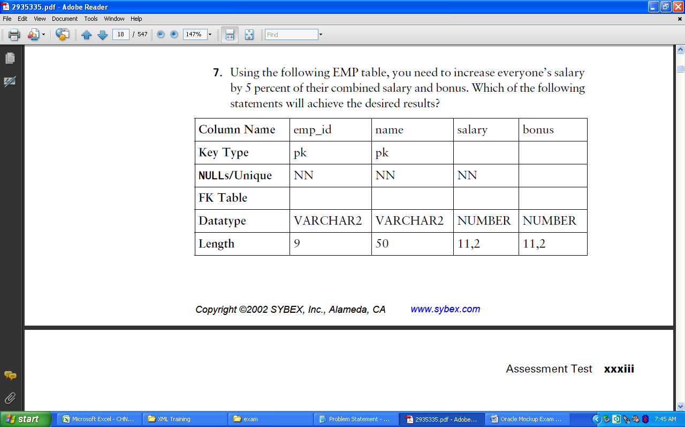

1. UPDATE emp SET salary = (salary + bonus)*1.05;
2. UPDATE emp SET salary = salary*1.05 + bonus*1.05;
3. UPDATE emp SET salary = salary + (salary + bonus)*0.05;
4. A, B, and C will achieve the desired results.
5. None of these statements will achieve the desired results.
6. The following statement will raise an exception on which line?

select dept_name, avg(all salary) ,count(*) “number of employees” from emp , dept where deptno = dept_no and count(*) > 5 group by dept_name order by 2 desc;

1. select dept_name, avg(all salary), count(*) “number of employees”
2. where deptno = dept_no
3. and count(*) > 5
4. group by dept_name
5. order by 2 desc;
6. Your HR department wants to recognize the most senior employees in each department. You need to produce a report with the following requirements:

*Display each department ID

*For each department, show the earliest hire date

*Show how many employees from each department were hired on the earliest hire date

Will all three requirements be met with the following SQL statement?

select department_id ,min(hire_date),count(*) keep (dense_rank last order by hire_date asc)

from hr.employees group by department_id;

1. The statement meets all three requirements.
2. The statement meets two of the three requirements.
3. The statement meets one of the three requirements.
4. The statement meets none of the three requirements.
5. The statement will raise an exception.
6. The DEPT table has the following data.

SQL> SELECT * FROM dept;

DEPTNO DNAME LOC

---------- -------------- ------

10 ACCOUNTING NEW YORK

20 RESEARCH DALLAS

30 SALES CHICAGO

40 OPERATIONS BOSTON

Consider this INSERT statement:

INSERT INTO (SELECT * FROM dept WHERE deptno = 10) VALUES (50, 'MARKETING', 'FORT WORTH');

Choose the best answer.

1. The INSERT statement is invalid; a valid table name is missing.
2. 50 is not a valid DEPTNO value, since the subquery limits DEPTNO to 10.
3. The statement will work without error.
4. A subquery and a VALUES clause cannot appear together.
5. At a minimum, how many join conditions should there be to avoid a Cartesian join if there are three tables in the FROM clause?
6. 1
7. 2
8. 3
9. There is no minimum.
10. Why does the following statement fail?

CREATE TABLE FRUITS&VEGETABLES ( NAME VARCHAR2 (40));

1. The table should have more than one column defined.
2. NAME is a reserved word, which cannot be used as a column name.
3. The table name is invalid.
4. Column length cannot exceed 30 characters.

13.Which datatype stores data outside the Oracle database?

1. UROWID
2. BFILE
3. BLOB
4. NCLOB
5. EXTERNAL

14.Which of the following statements are true? (Choose all that apply.)

1. Primary key constraints allow NULL values in the columns.
2. Unique key constraints allow NULL values in the columns.
3. Primary key constraints do not allow NULL values in columns.
4. A nonunique index cannot be used to enforce a primary key constraint

15.Which operation cannot be performed using the ALTER TABLE statement?

1. Rename table
2. Rename column
3. Drop column
4. Drop NOT NULL constraint

16. Which data dictionary table should you query to view the object privileges granted to the user on specific columns?

1. USER_TAB_PRIVS_MADE
2. USER_TAB_PRIVS
3. USER_COL_PRIVS_MADE
4. USER_COL_PRIVS

17. Which three are DATETIME data types that can be used when specifying column definitions? (Choose three)

1. TIMESTAMP
2. INTERVAL MONTH TO DAY
3. INTERVAL DAY TO SECOND
4. INTERVAL YEAR TO MONTH
5. TIMESTAMP WITH DATABASE TIMEZONE

18. Which syntax turns an existing constraint on?

1. ALTER TABLE table_name ENABLE constraint_name
2. ALTER TABLE table_name STATUS = ENABLE CONSTRAINT constraint_name
3. ALTER TABLE table_name ENABLE CONSTRAINT constraint_name
4. ALTER TABLE table_name STATUS ENABLE CONSTRAINT constraint_name
5. ALTER TABLE table_name TURN ON CONSTRAINT constraint_name
6. ALTER TABLE table_name TURN ON CONSTRAINT constraint_name

19. Which two statements about views are true? (Choose two)

1. A view can be created as read only
2. A view can be created as a join on two or more tables.
3. A view cannot have an ORDER BY clause in the SELECT statement.
4. A view cannot be created with a GROUP BY clause in the SELECT statement.
5. A view must have aliases defined for the column names in the SELECT statement.

20. The database administrator of your company created a public synonym called HR for the HUMAN_RESOURCES table of the GENERAL schema, because many users frequently use this table. As a user of the database, you created a table called HR in your schema. What happens when you execute this query?

**SELECT * FROM HR;**

1. you obtain the results retrieved from the public synonym HR created by the database administrator
2. You obtain the results retrieved form the HR table that belongs to your schema.
3. you get an error message because you cannot retrieve from a table that has the same as a public synonym
4. You obtain the results retrieved from both the public synonym HR and the HR table that belongs to your schema, as a Cartesian product.
5. You obtain the results retrieved form both the public synonym HR and the HR table that belongs to your schema, as a FULL JOIN.